**SPORTS WEEK FA-24**

**BOOTSTRAP 5 FOR RESPONSIVE DESIGN**

I used Bootstrap 5 for responsive design, providing pre-built classes and components to create a clean, mobile-friendly layout with custom CSS.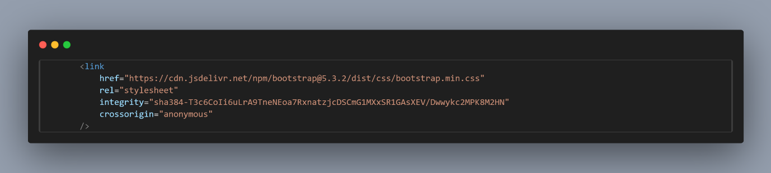

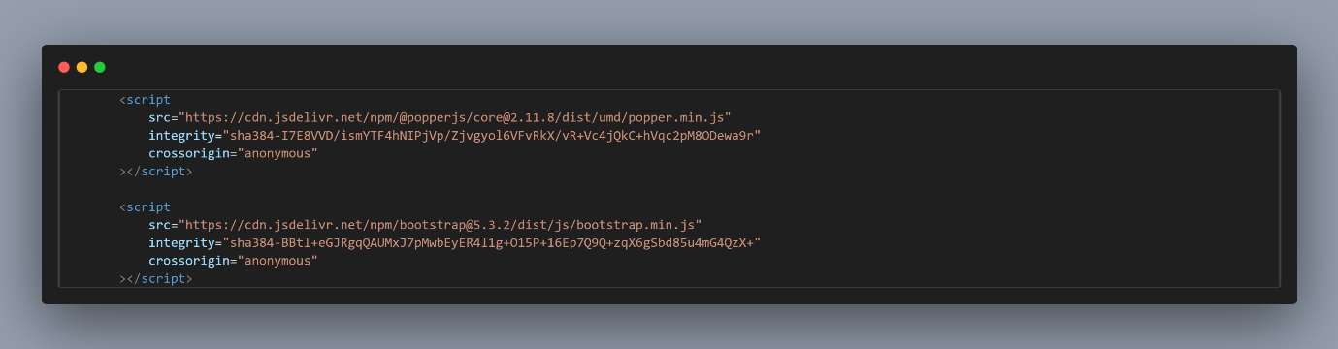

**ICONS**

This line of code adds a favicon (comsats logo) to the webpage. The icon file, comsats-icon.ico, is located in the Images directory and is set to be a .jpeg format.

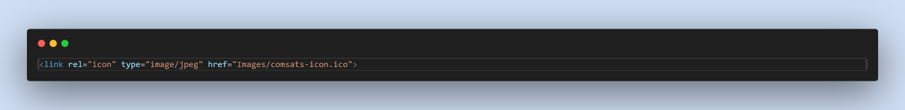

These lines import two icon libraries: Bootstrap Icons for vector icons styled with Bootstrap, and Font Awesome for a wide variety of scalable icons.

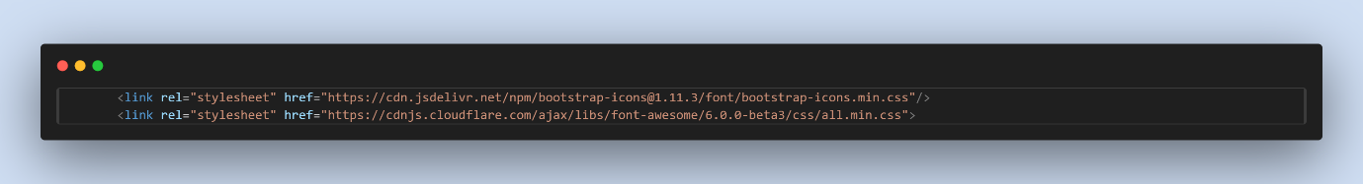

**RESPONSIVE NAVBAR**

This code creates a responsive navigation bar using Bootstrap 5, ensuring compatibility across different screen sizes. The navbar is fixed at the top of the page and expands into a dropdown menu on smaller screens. It features a brand name "COMSATS Wah" and includes navigation links to sections like Home, Events, About, and Contact. The Bootstrap utility classes like navbar-expand-lg and navbar-light handle

responsiveness and appearance, while ms-auto aligns the navigation links to the right.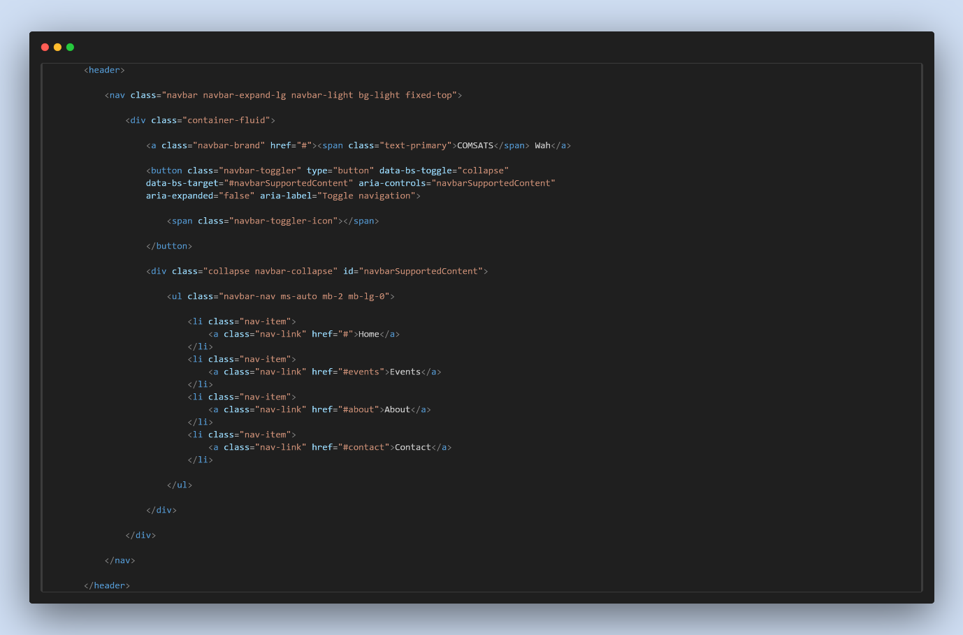

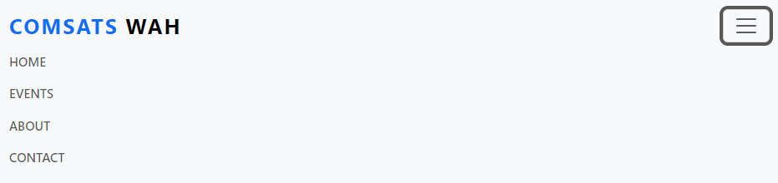

**Event Carousel**

These buttons are carousel indicators that enable users to navigate directly to specific slides in the Bootstrap 5 carousel. Each button is linked to a slide using data-bs-target and data-bs-slide-to, with the active class indicating the current slide for improved accessibility.

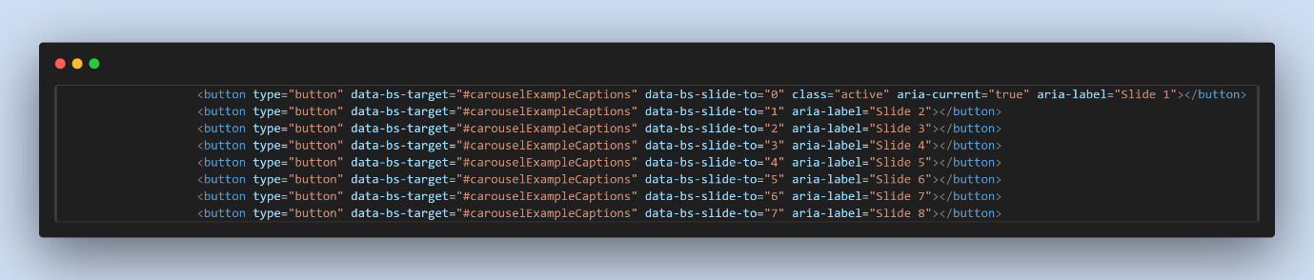

This code represents an active carousel item featuring an esports event. It includes an image, a title ("Esports"), a description inviting participants to join, and a "Learn More" button linking to further details.

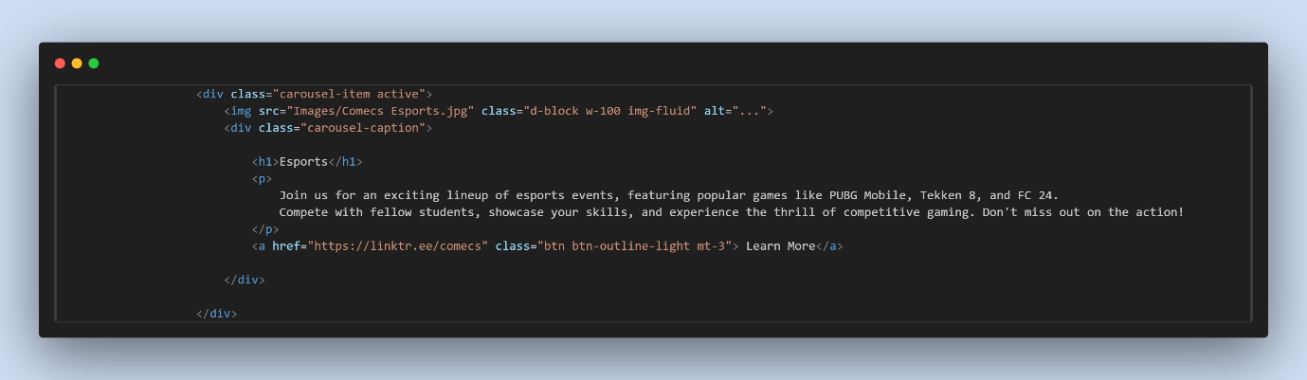

These buttons control navigation in the Bootstrap 5 carousel, allowing users to move to the previous or next slide. They use data-bs-target to link to the carousel, with accessibility features like aria-hidden and visually-hidden.

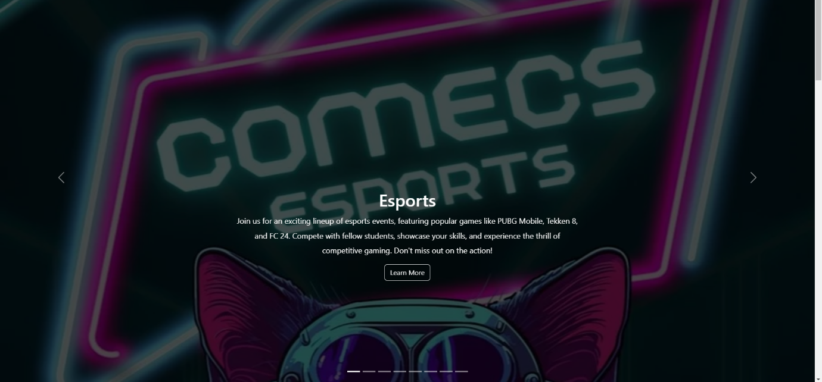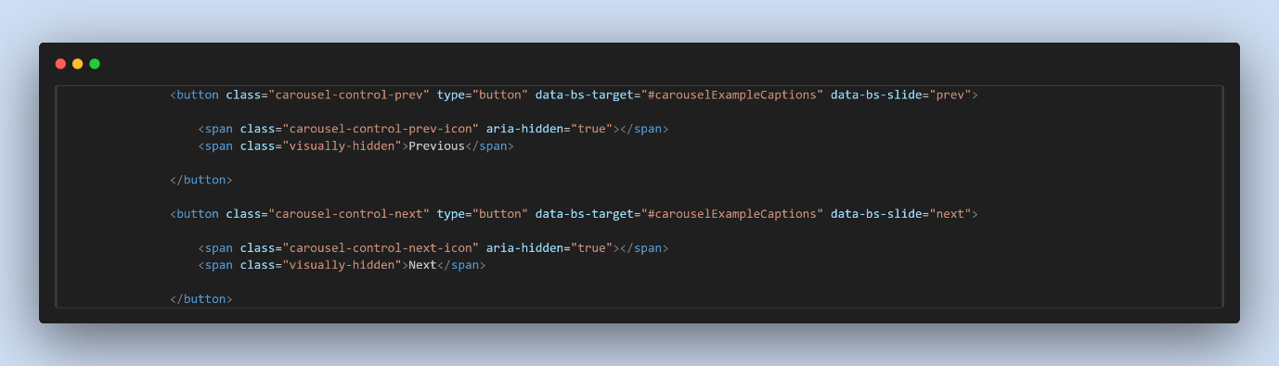

**BOOTSTRAP 5 CARDS**

This code creates a responsive card layout using Bootstrap 5. It features a Bootstrap row and column that adjust for various screen sizes. The card has a blue background with white text and includes a gaming icon, a title, and a description. A registration button encourages users to sign up, ensuring a visually appealing and user-friendly experience.

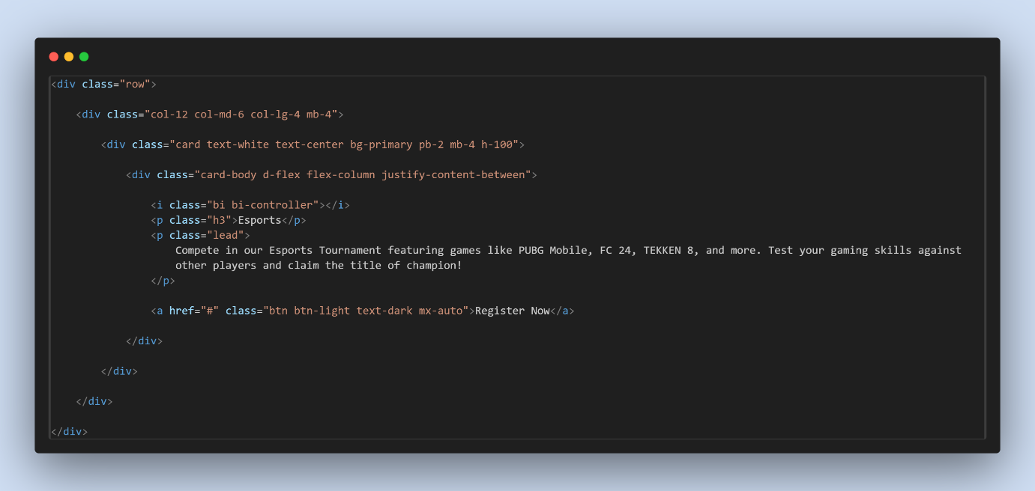

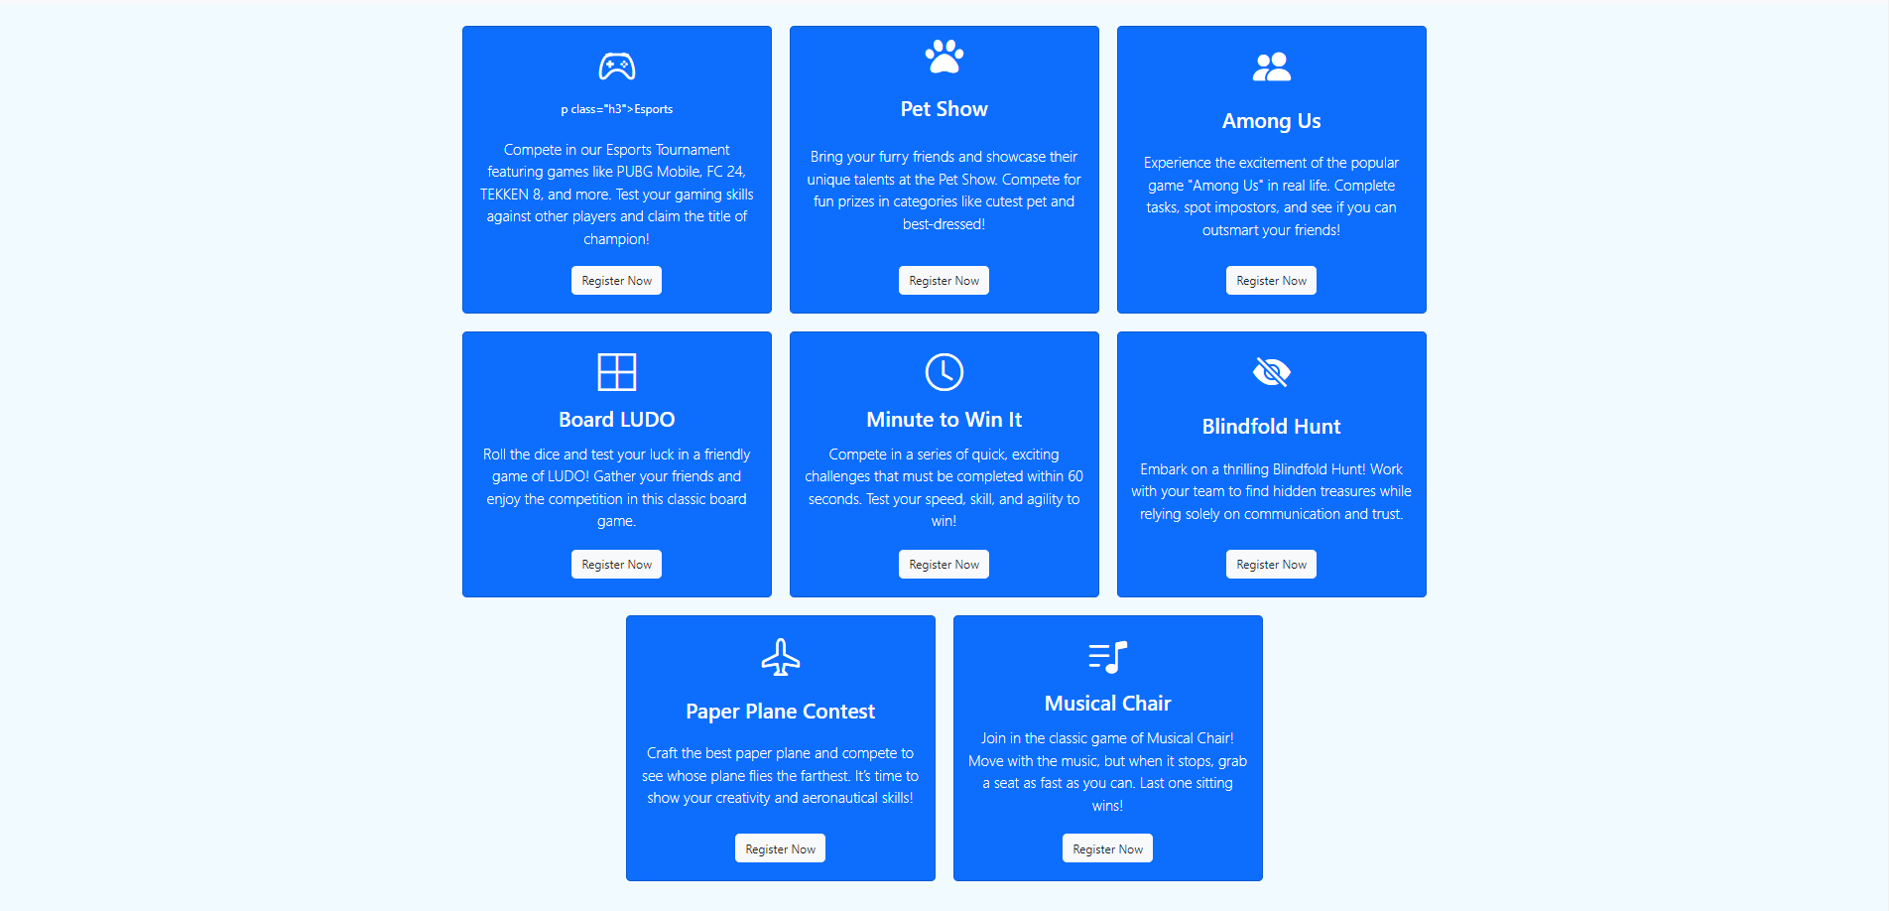

**ABOUT US SECTION**

This code creates a responsive "About" section for COMSATS University Islamabad, Wah Campus. It includes a heading and a brief description of the university's focus on quality education and innovation, along with a "Learn More" button for further exploration. This layout effectively presents essential information in a clean design.

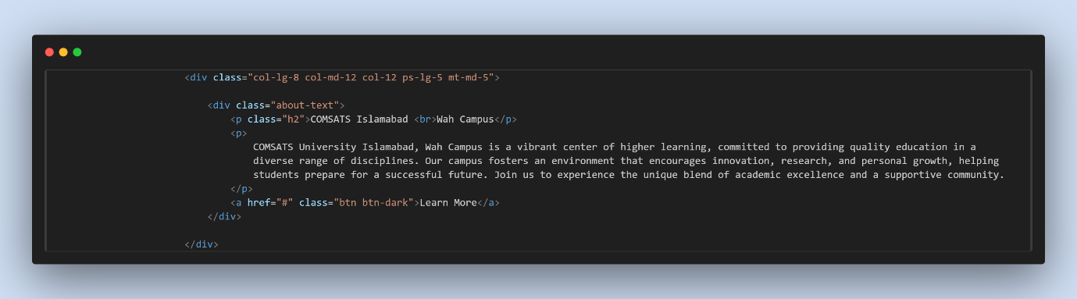

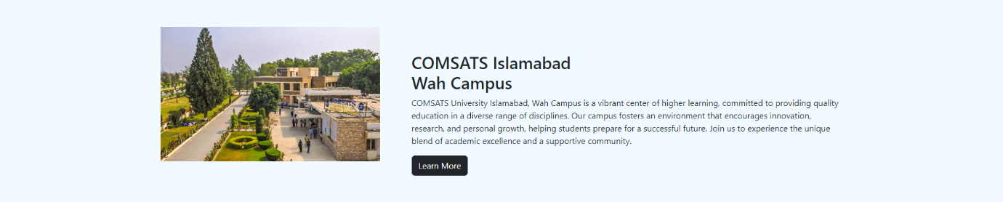

**CONTACT US FORM**

The code creates a responsive contact form for user inquiries. It includes fields for the user's full name, email address, and a text area for their query, all required for submission. A "Send Now" button allows users to easily submit their inquiries, ensuring a user-friendly experience.

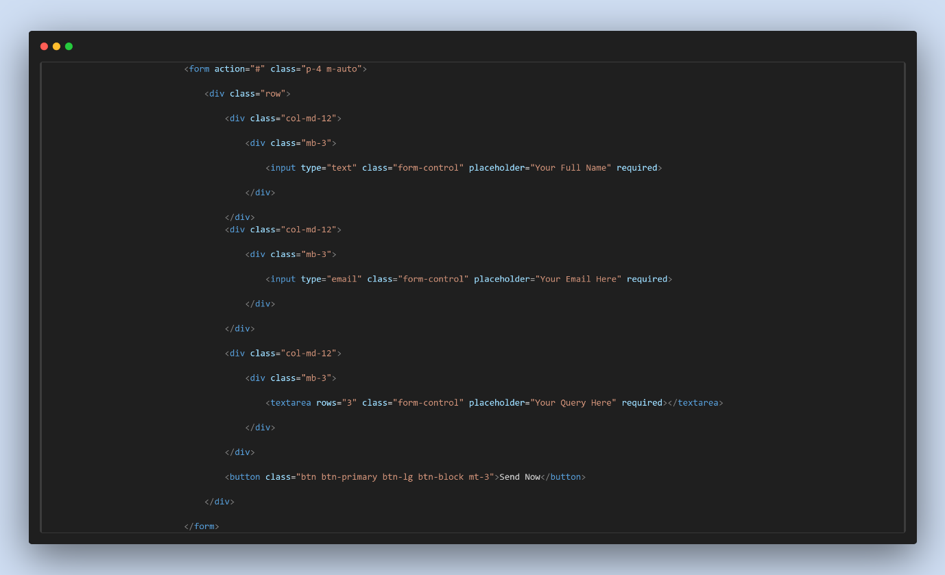

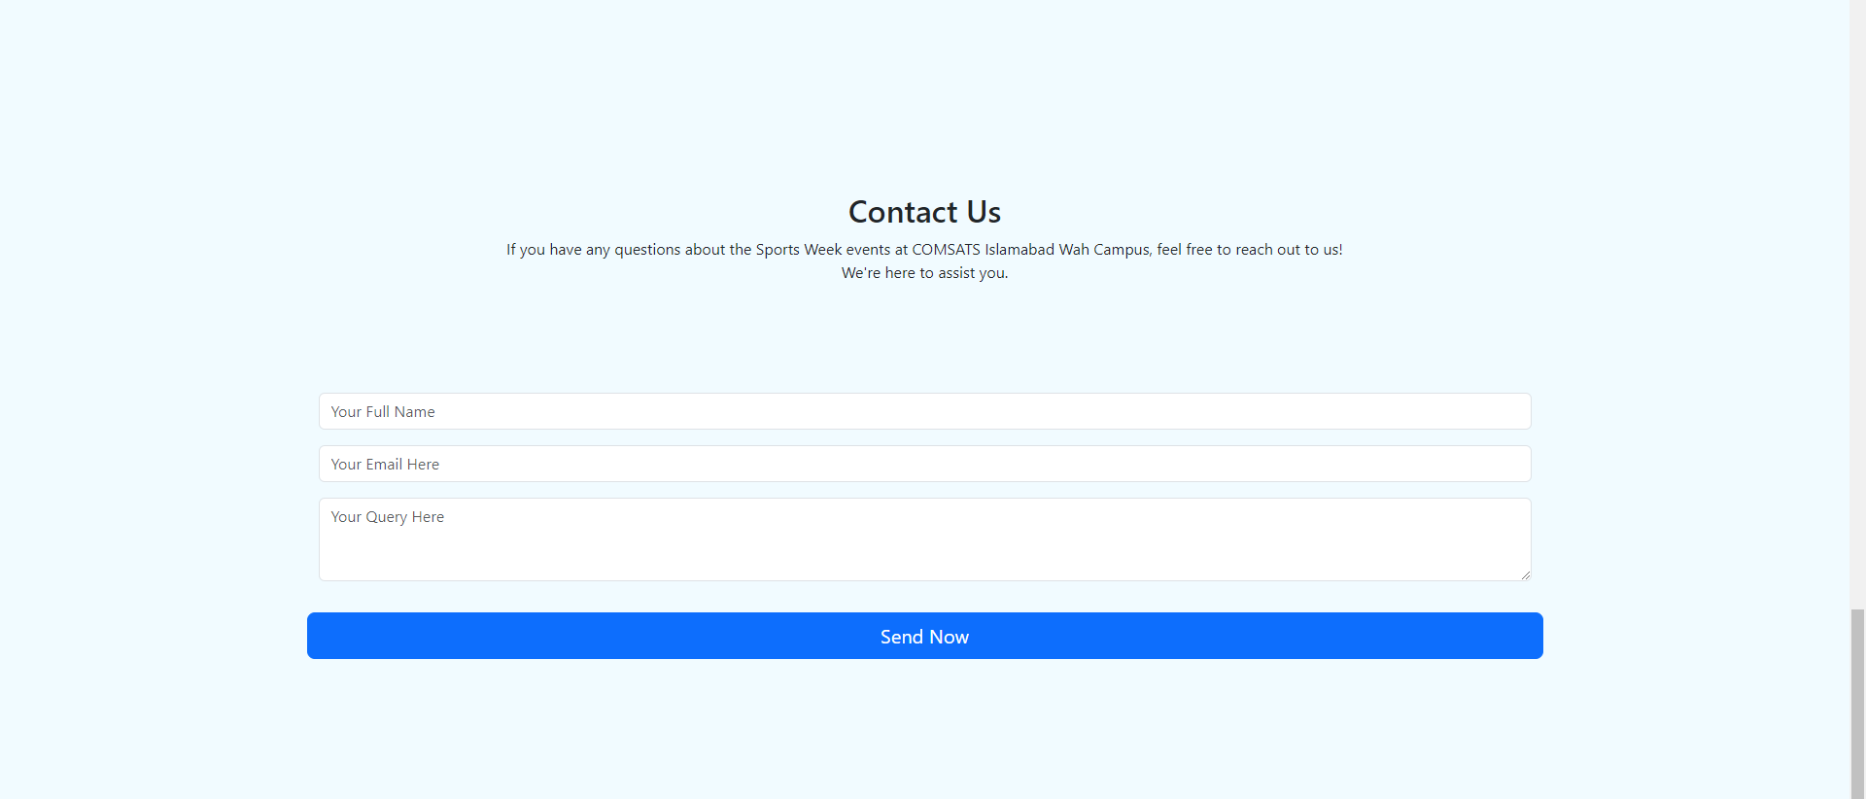

**FOOTER SECTION**

The code snippet creates a footer with a dark background that displays a copyright message and a link. This section provides essential information in a clean design.

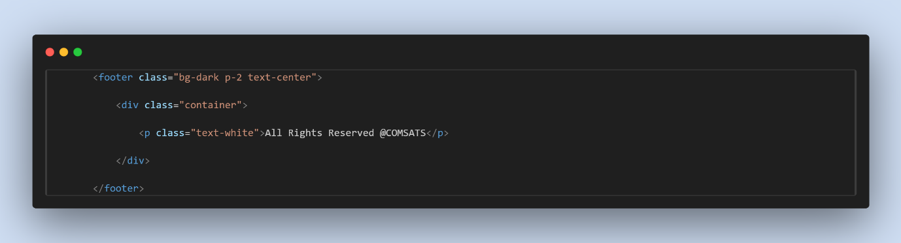



**Google Drive**

https://drive.google.com/drive/folders/1tK0O25hK0_1WUQWrU1xrOWUMHFj5pmbb